**PROJECT TITLE: "ENHANCING CLEANING PRACTICES IN URBAN COMMUNITIES"**

**Executive Summary**

Our innovative project aims to revolutionize the cleaning industry in South Sudan by targeting the growing demand for high-quality cleaning services in Juba City and across various South Sudan states. With a focus on scalability, sustainability, and meeting the needs of diverse consumer segments, our project is poised to create significant value for stakeholders across the value chain.

**Key Target Markets**

* **Juba City's Growing Population:** We will cater to the increasing demand for quality cleaning services driven by a rising urban population seeking high-standard cleaning solutions.
* **Hospitality Sector (Hotels, Restaurants):** Our premium cleaning services will be tailored to meet the exacting standards of hotels, restaurants, and cafes, ensuring consistent quality and hygiene.
* **Institutional Clients (Offices, Schools):** Collaborating with institutional clients and bulk purchasers will ensure a steady market for large-scale cleaning services, providing a stable revenue stream for the company.

**Value Proposition**

* **High-Quality Cleaning Services:** Through modern cleaning techniques, optimal cleaning products, and well-trained staff, we guarantee top-quality services that meet and exceed market expectations.
* **Sustainable Practices:** Our project emphasizes eco-friendly cleaning practices, utilizing biodegradable cleaning products. This not only reduces environmental impact but also contributes to healthier living and working environments.
* **Market Expansion and Profitability:** By tapping into diverse market segments and fostering strong partnerships with key stakeholders, we aim to drive profitability for the cleaning company while meeting the growing consumer demand.

**Project Objectives**

* Establish state-of-the-art cleaning facilities equipped with modern infrastructure for optimal service delivery.
* Implement advanced training programs to enhance staff skills for improved service quality and efficiency.
* Forge strategic partnerships with hospitality businesses, institutions, and bulk clients to secure long-term market demand and profitability.
* Conduct outreach programs to educate local communities on sustainable cleaning practices and the benefits of eco-friendly products.
* Ensure compliance with industry standards, hygiene protocols, and ethical business practices to deliver safe and premium cleaning services to clients.

**Expected Outcomes**

* Increased provision of high-quality cleaning services to meet market demand.
* Improved livelihoods for cleaning staff through enhanced profitability and market access.
* Contribution to environmental conservation through sustainable cleaning practices.
* Strengthening of South Sudan's cleaning industry competitiveness in locally in all states.

**Promoter**

**HAGANA CLEANING SERVICES CO. LTD. LOCATION OF THE PROJECT:** JEBEL JUBA-SOUTH SUDAN.  
**ESTIMATED COST OF THE PROJECT:**

* Owners (shareholders) contribution to the project: $15,000 USD.
* Need of financing: $5000 USD
* This will be acquired from the Commercial banks or any other financers or investors who are willing to invest in this project.

**Project Profitability**

**Unlocking Lucrative Opportunities in South Sudan's Booming Cleaning Industry:**  
Our project stands as a beacon of profitability within South Sudan's thriving service sector, particularly in the lucrative cleaning industry. The inherent profitability stems from several key factors that underscore the viability and sustainability of our venture.

**Socio-Economic Advantages of this Project**

1. **Employment Generation:**
   * **Direct Employment:** The project will create jobs for cleaners, supervisors, and administrative staff involved in cleaning operations.
   * **Indirect Employment:** Supporting industries such as cleaning product suppliers, equipment manufacturers, and transportation services will also experience increased demand, leading to additional job opportunities.
2. **Income Diversification and Poverty Reduction:**
   * Small-scale entrepreneurs and urban communities can diversify their income sources by participating in cleaning services, reducing their dependency on a single livelihood.
   * Increased household income from cleaning services and related activities can contribute to poverty alleviation and improved standards of living.
3. **Health and Hygiene Improvement:**
   * Increased provision of quality cleaning services contributes to improved hygiene in homes, offices, and public spaces, enhancing overall public health.
   * Access to professional cleaning services improves living conditions, especially in communities where hygiene standards are lacking.

**Stakeholder Benefits**

1. **Small-Scale Cleaning Entrepreneurs:**
   * Entrepreneurs engaged in cleaning activities will directly benefit from increased income through the provision of cleaning services.
   * Access to training, technology, and market linkages provided by the project will empower entrepreneurs to improve their practices, productivity, and profitability.
2. **Urban Communities:**
   * Communities residing in urban areas where cleaning services are prevalent will experience economic upliftment and improved standards of living.
   * Diversification of income sources and employment opportunities within the community contribute to poverty reduction and socio-economic development.
3. **Hospitality and Institutional Clients:**
   * Hotels, restaurants, offices, and schools will benefit from high-quality cleaning services that ensure hygienic environments and customer satisfaction.
   * Enhanced service standards and reliability ensure confidence and satisfaction among clients.
4. **Consumers:**
   * Consumers in Juba City, other urban areas, and rural communities benefit from access to quality cleaning services at affordable prices, contributing to improved health and living conditions.
   * Enhanced service standards and reliability ensure confidence and satisfaction among consumers.
5. **Government and Regulatory Bodies:**
   * The government benefits from increased tax revenues generated from expanded economic activities in the cleaning services sector.
   * Regulatory bodies benefit from improved compliance with industry standards, health and safety practices, and environmental regulations.
6. **Environmental Stakeholders:**
   * Sustainable cleaning practices promoted by the project, such as the use of biodegradable products, benefit the environment by reducing pollution and promoting eco-friendly practices.
   * Environmental stakeholders and conservation organizations appreciate initiatives that promote eco-friendly cleaning practices.
7. **Research and Academic Institutions:**
   * Research institutions and universities benefit from collaborative research opportunities, knowledge exchange, and data sharing related to cleaning technologies, health management, and sustainable practices.

**General Information**

**Promoter**  
Name: Hagana Cleaning Services Co. Ltd  
Place of business: The project will be located in Jebel: Market, Juba South Sudan.  
Contact: +211922104848/+250733197651.

**Professional Experience:**  
The manager has been operating within the same industry in Kigali Rwanda for the past two years, showcasing significant capabilities in effectively managing this business. Given this experience and expertise, he is well-positioned to successfully run a similar business in South Sudan.

**Financial Information of the Owner:**  
The financial structure of Hagana Cleaning Services Co. Ltd reveals it as a family-owned enterprise, with ownership shared among two shareholders. Notably, one of these shareholders is actively engaged in government roles within South Sudan. This unique dynamic reflects a blend of private sector acumen and public sector insight within the business leadership, which can be perceived as a strategic advantage, especially in navigating regulatory landscapes and fostering beneficial partnerships.

**Hagana Cleaning Services Co. Ltd Assets**

* 160sqm plot in Sharkat as store
* Intended to purchase vehicles for operations and pickups for delivery of cleaning equipment and transportation of cleaning staff to different client locations.

**Debts:**  
The company stands debt-free due to its strategic reliance on internal capital for operations. This prudent financial approach underscores the company's strong fiscal discipline and prudent management practices, positioning it as a highly attractive prospect for investors seeking stability and growth potential.

**Project Concept**

The country has implemented policies aimed at encouraging investment across various sectors, with a particular emphasis on service industries like cleaning. This initiative is designed to decrease reliance on imported cleaning services and products, thereby boosting the local economy. Additionally, these policies seek to stimulate the growth of the cleaning industry locally, ultimately reducing the need for services from neighbouring countries. By promoting investment in cleaning services and supporting the development of domestic industries, the country aims to enhance self-sufficiency, create employment opportunities, and strengthen its service sector.

**HAGANA CLEANING SERVICES PROJECT DESCRIPTION**

Our project focuses on maximizing the productivity of a 160sqm operational base by strategically segmenting it into different functional areas: one for office operations and training, and the other for equipment storage and maintenance. This segmentation allows us to precisely determine the optimal use of resources, ensuring efficient operations and maximizing commercial output.

**Office and Training Section:**

* Implementing precision operational techniques to accommodate the ideal number of staff per square meter, optimizing their productivity and health.
* Utilizing modern office and training systems tailored to staff welfare and productivity, resulting in premium-quality services.
* Incorporating data-driven management practices for accurate monitoring of staff performance, training schedules, and service quality, leading to improved overall profitability.

**Equipment Storage and Maintenance Section:**

* Designing custom storage areas for cleaning equipment and supplies, promoting efficient space utilization and easy access.
* Implementing regular maintenance practices to ensure equipment longevity and optimal performance.
* Introducing advanced inventory management systems to enhance the quality-of-service supplies, catering to high-end market demands.

**Business Value**

* **Optimized Resource Utilization:** By accurately segmenting the operational base, we ensure optimal use of land and resources, reducing waste and increasing overall efficiency.
* **Premium Service Quality:** Our focus on staff welfare, modern training techniques, and data-driven management translates into superior quality cleaning services, commanding premium prices in the market.
* **Market Differentiation:** The strategic division of the operational base allows us to target specific customer segments, catering to diverse market demands and expanding revenue streams.
* **Sustainability:** Implementing eco-friendly cleaning practices and modern operational techniques not only boosts productivity but also promotes environmentally sustainable services, aligning with market trends and regulatory standards.

**Service Program Section**

**Our services are subdivided into different categories as discussed below**:

**Residential Cleaning:** These services are designed for private homes and apartments, offering comprehensive cleaning solutions including dusting, vacuuming, mopping, and more

**Commercial Cleaning:** Commercial cleaning services cater to offices, retail stores, and other business premises, ensuring a clean and hygienic working environment. 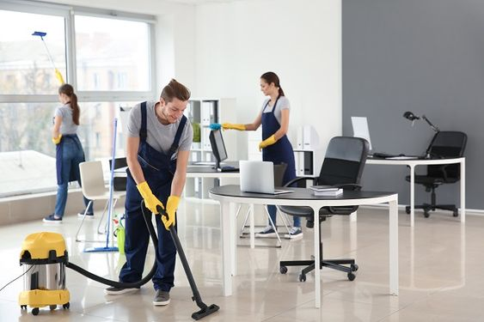

**Specialized Cleaning:** Some cleaning services are designed for specific purposes such as post-construction cleaning, deep cleaning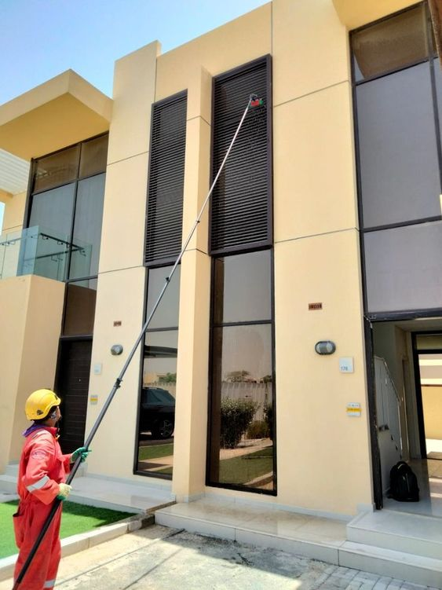

IMAGES OF WHAT WE DO AS A LEADING COMMERCIAL AND RESIDENTIAL CLEANING COMPANY IN JUBA.

* 1. Vacuum cleaning 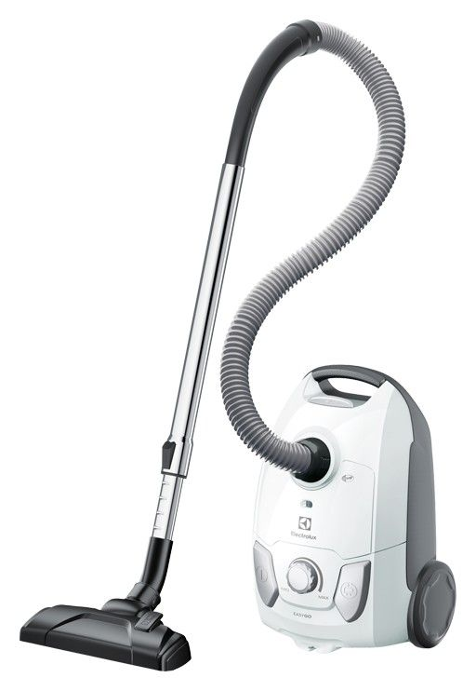
  2. Spider web cleaning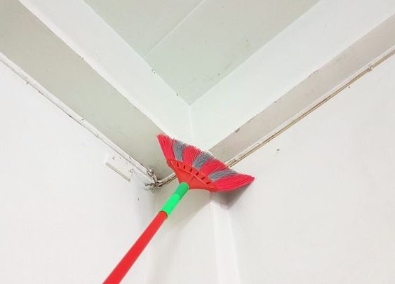
  3. Car cleaning/ washing
  4. Deep cleaning

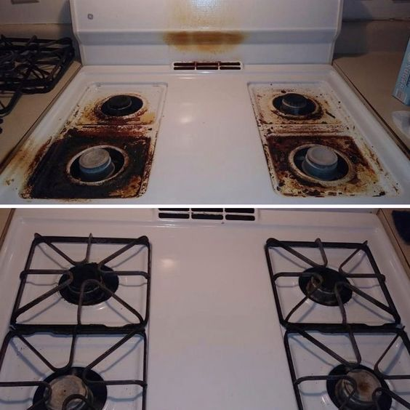

* 1. Carpet Cleaning. 
  2. Kitchen cleaning 
  3. Bedroom laying 
  4. Toilet cleaning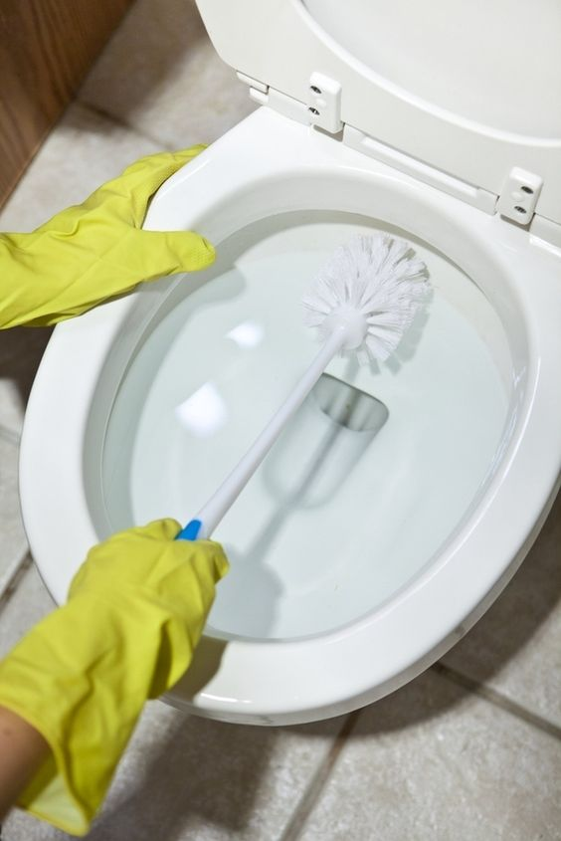
  5. Compound layout
  6. Bed bug
  7. Mosquitoes 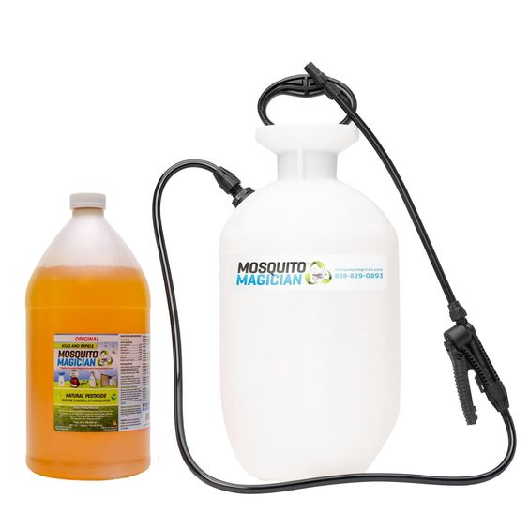
  8. Dog treatment. (Wound infection) 